What's the difference between a team and a channel?
A team is a group of people gathered to get something big done in your organisation. Sometimes it’s your whole organisation but most of the times it will be your team or department. It could also be a specific project you are working on.
Teams are made up of channels, which are the conversations you have with your teammates. Each channel is dedicated to a specific topic, department, or project.
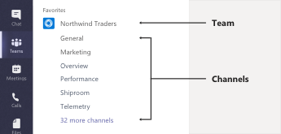
For example, the Northwind Traders team has General, Marketing, Overview, and 35 more channels. All the conversations, meetings, files, and apps in the Marketing channel have to do with marketing, and everything in this channel is visible to everyone on the Northwind Traders team. Channels are an efficient way to bundle all related content into one location (rather than having several different Teams!).
Channels are where the work actually gets done—where text, audio, and video conversations open to the whole team happen and where files are shared.
So when you are about to request a Team, please ask yourself if the reason for the Team would not be more reasonable to be a channel under a Team that already exists. Again, this will help keep related content together.

Examples:
If you already have a Team called “Finance Department”, and you are wondering if you should request a new Team for your Month End process or rather create a channel, the answer will probably be to create a channel. Month End is a department-related activity so it would make sense to keep it there, where related content can be stored and the people you would need are also already in.

If there is something that is relating to the overall Team but contains sensitive information, please consider creating a private channel instead of a Team. An example could be your overall Team is “Finance”, it has several channels like “General”, “Month End”, “Year End”, “Weekly catch up”, etc. but you are currently also hiring. This is finance department related but not everyone in your department should be able to see anything related to the interview preparation you might have. You could create a private channel called “Hiring Interview Prep” and only invite a select number of people of the Team into this channel. This would save you from creating a new Team for something that would sit much better with your overall Team.

